Configure an Internal Network Load Balancer
experimentLabschedule45 minutesuniversal_currency_altNo costshow_chartIntroductory
infoThis lab may incorporate AI tools to support your learning.

Overview
Google Cloud offers internal Network Load Balancing for your TCP/UDP-based traffic. Internal Network Load Balancing enables you to run and scale your services behind a private load balancing IP address that is accessible only to your internal virtual machine instances.
In this lab, you create two managed instance groups in the same region. Then you configure and test an internal Network Load Balancer with the instances groups as the backends, as shown in this network diagram:
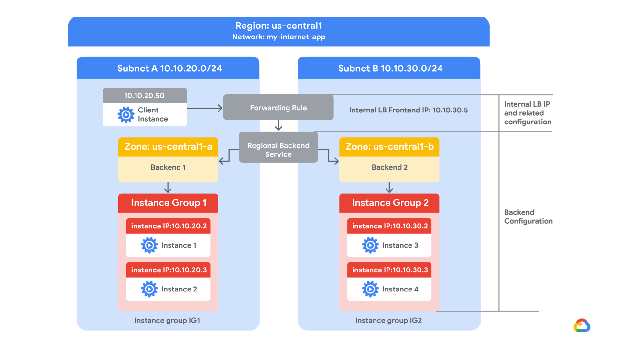

Objectives
In this lab, you will learn how to perform the following tasks:
- Create internal traffic and health check firewall rules.
- Create a NAT configuration using Cloud Router.
- Configure two instance templates.
- Create two managed instance groups.
- Configure and test an internal Network Load Balancer.

Setup and requirements
For each lab, you get a new Google Cloud project and set of resources for a fixed time at no cost.
- Click the Start Lab button. If you need to pay for the lab, a pop-up opens for you to select your payment method. On the left is the Lab Details panel with the following:
  - The Open Google Cloud console button
  - Time remaining
  - The temporary credentials that you must use for this lab
  - Other information, if needed, to step through this lab
- Click Open Google Cloud console (or right-click and select Open Link in Incognito Window if you are running the Chrome browser).
The lab spins up resources, and then opens another tab that shows the Sign in page.
Tip: Arrange the tabs in separate windows, side-by-side.
- Note: If you see the Choose an account dialog, click Use Another Account.
- If necessary, copy the Username below and paste it into the Sign in dialog.
- "Username"
- Copied!
- You can also find the Username in the Lab Details panel.
- Click Next.
- Copy the Password below and paste it into the Welcome dialog.
- "Password"
- Copied!
- You can also find the Password in the Lab Details panel.
- Click Next.
- Important: You must use the credentials the lab provides you. Do not use your Google Cloud account credentials.
- Note: Using your own Google Cloud account for this lab may incur extra charges.
- Click through the subsequent pages:
  - Accept the terms and conditions.
  - Do not add recovery options or two-factor authentication (because this is a temporary account).
  - Do not sign up for free trials.
After a few moments, the Google Cloud console opens in this tab.
Note: To view a menu with a list of Google Cloud products and services, click the Navigation menu at the top-left, or type the service or product name in the Search field. 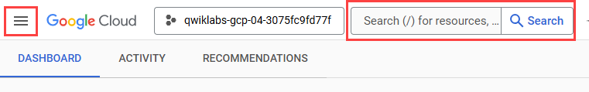

Task 1. Configure internal traffic and health check firewall rules
In this task, you configure firewall rules to allow internal traffic connectivity and health check probes for your application. You explore the existing network and create new firewall rules to permit traffic from specified IP ranges.
Configure firewall rules to allow internal traffic connectivity from sources in the 10.10.0.0/16 range. This rule allows incoming traffic from any client located in the subnet.
Health checks determine which instances of a load balancer can receive new connections. For Application Load Balancing (HTTP), the health check probes to your load-balanced instances come from addresses in the ranges 130.211.0.0/22 and 35.191.0.0/16. Your firewall rules must allow these connections.

Explore the my-internal-app network
The network my-internal-app with subnet-a and subnet-b and firewall rules for RDP, SSH, and ICMP traffic have been configured for you.
- In the Google Cloud console, in the Navigation menu (), click VPC network > VPC networks.
Notice the my-internal-app network with its subnets: subnet-a and subnet-b.
Each Google Cloud project starts with the default network. In addition, the my-internal-app network has been created for you as part of your network diagram.
You will create the managed instance groups in subnet-a and subnet-b. Both subnets are in the Region region because an internal Network Load Balancer is a regional service. The managed instance groups will be in different zones, making your service immune to zonal failures.

Create the firewall rule to allow traffic from any sources in the 10.10.0.0/16 range
Create a firewall rule to allow traffic in the 10.10.0.0/16 subnet.
- On the Navigation menu (), click VPC network > Firewall.
Notice the app-allow-icmp and app-allow-ssh-rdp firewall rules.
These firewall rules have been created for you.
- Click Create firewall rule.
- Specify the following, and leave the remaining settings as their defaults.
Property | Value (type value or select option as specified)
Name | fw-allow-lb-access
Network | my-internal-app
Targets | Specified target tags
Target tags | backend-service
Source filter | IPv4 ranges
Source IPv4 ranges | 10.10.0.0/16
Protocols and ports | Allow all
Note: Make sure to include the /16 in the Source IPv4 ranges.
- Click Create.

Create the health check rule
Create a firewall rule to allow health checks.
- On the Navigation menu (), click VPC network > Firewall.
- Click Create firewall rule.
- Specify the following, and leave the remaining settings as their defaults.
Property | Value (type value or select option as specified)
Name | fw-allow-health-checks
Network | my-internal-app
Targets | Specified target tags
Target tags | backend-service
Source filter | IPv4 Ranges
Source IPv4 ranges | 130.211.0.0/22 and 35.191.0.0/16
Protocols and ports | Specified protocols and ports
Note: Make sure to include the /22 and /16 in the Source IPv4 ranges.
- For tcp, check the checkbox and specify port 80.
- Click Create.
Click Check my progress to verify the objective.
Configure internal traffic and health check firewall rules

Task 2. Create a NAT configuration using Cloud Router
In this task, you create a Cloud Router instance and configure Cloud NAT to enable your backend instances to send outbound traffic.
The Google Cloud VM backend instances that you setup in Task 3 will not be configured with external IP addresses.
Instead, you will setup the Cloud NAT service to allow these VM instances to send outbound traffic only through the Cloud NAT, and receive inbound traffic through the load balancer.

Create the Cloud Router instance
- On the Google Cloud console title bar, type Network services in the Search field, then click Network services in the Products & pages section.
- On the Network service page, click Star next to Network services.
- Click Cloud NAT.
- Click Get started to configure a NAT gateway.
- Specify the following, and leave the remaining settings as their defaults.
Property | Value (type value or select option as specified)
Gateway name | nat-config
Network | my-internal-app
Region | Region
- Click Cloud Router, and select Create new router.
- For Name, type nat-router-Region.
- Click Create.
- In Create Cloud NAT gateway, click Create.
Note: Wait until the NAT Gateway Status changes to Running before moving onto the next task.
Click Check my progress to verify the objective.
Create a NAT configuration using Cloud Router

Task 3. Configure instance templates and create instance groups
In this task, you verify the pre-configured instance templates and managed instance groups. You execute startup scripts on the existing instances and create a utility VM to test connectivity to the backend instances.
A managed instance group uses an instance template to create a group of identical instances. Use these to create the backends of the internal Network Load Balancer.
This task has been performed for you at the start of this lab. You will need to SSH into each instance group VM and run the following command to setup the environment.
- On the Navigation menu, click Compute Engine > VM instances.
Notice the instances that start with instance-group-1 and instance-group-2.
- Select the SSH button next to instance-group-1 to SSH into the VM.
- If prompted, allow SSH-in-browser to connect to VMs, click Authorize.
- Run the following command to re-run the instance's startup script:
sudo google_metadata_script_runner startup
Copied!
- Repeat the previous steps for instance-group-2.
- Wait for both startup scripts to finish executing, then close the SSH terminal to each VM. The output of the startup script should state the following:
Finished running startup scripts.

Verify the backends
Verify that VM instances are being created in both subnets and create a utility VM to access the backends' HTTP sites.
- On the Navigation menu, click Compute Engine > VM instances.
Notice the instances that start with instance-group-1 and instance-group-2.
These instances are in separate zones, and their internal IP addresses are part of the subnet-a and subnet-b CIDR blocks.
- Click Create instance.
- For the Machine configuration page, specify the following, and leave the remaining settings as their defaults:
Property | Value (type value or select option as specified)
Name | utility-vm
Region | Region
Zone | Zone 3
Series | E2
Machine type | e2-medium (2 vCPU, 4 GB memory)
- Click OS and storage.
- If the Image shown is not Debian GNU/Linux 12 (bookworm), click Change and select Debian GNU/Linux 12 (bookworm), and then click Select.
- Click Networking.
- For Network interfaces, click the dropdown to edit the network interface.
- Specify the following, and leave the remaining settings as their defaults.
Property | Value (type value or select option as specified)
Network | my-internal-app
Subnetwork | subnet-a
Primary internal IPv4 address | Ephemeral (Custom)
Custom ephemeral IP address | 10.10.20.50
External IPv4 address | None
- Click Done.
- Click Create.
- Note that the internal IP addresses for the backends are 10.10.20.2 and 10.10.30.2.
Note: If these IP addresses are different, replace them in the two curl commands below.
Click Check my progress to verify the objective.
Configure instance templates and create instance groups
- For utility-vm, click SSH to launch a terminal and connect.
- If prompted allow SSH-in-browser to connect to VMs, click Authorize.
- To verify the welcome page for instance-group-1-xxxx, run the following command:
curl 10.10.20.2
Copied!
The output should look like this.
Output:
<h1>Internal Load Balancing Lab</h1><h2>Client IP</h2>Your IP address : 10.10.20.50<h2>Hostname</h2>Server Hostname:
instance-group-1-1zn8<h2>Server Location</h2>Region and Zone:
- To verify the welcome page for instance-group-2-xxxx, run the following command:
curl 10.10.30.2
Copied!
The output should look like this.
Output:
<h1>Internal Load Balancing Lab</h1><h2>Client IP</h2>Your IP address : 10.10.20.50<h2>Hostname</h2>Server Hostname:
instance-group-2-q5wp<h2>Server Location</h2>Region and Zone:
Which of these fields identify the location of the backend?
Client IP
Server Location
Server Hostname
Note: This will be useful when verifying that the internal load balancer sends traffic to both backends.
- Close the SSH terminal to utility-vm:
exit
Copied!

Task 4. Configure the internal Network Load Balancer
In this task you configure the internal Network Load Balancer to balance traffic between the two backends (instance-group-1 in Zone 1 and instance-group-2 in Zone 2), as illustrated in the network diagram.


Start the configuration
- On the Google Cloud console title bar, type Network services in the Search field, then click Network services in the Products & pages section > Load balancing.
- Click + Create load balancer.
- For Type of load balancer, select Network Load Balancer (TCP/UDP/SSL), click Next.
- For Proxy or passthrough, select Passthrough load balancer and click Next.
- For Public facing or internal, select Internal and click Next.
- For Create load balance, click Configure.
- For Load Balancer name, type my-ilb.
- For Region, type Region.
- For Network, select my-internal-app from the dropdown.

Configure the regional backend service
The backend service monitors instance groups and prevents them from exceeding configured usage.
- Click Backend configuration.
- Specify the following, and leave the remaining settings as their defaults.
Property | Value (select option as specified)
Instance group | instance-group-1 (Zone 1)
- Click Done.
- Click Add a backend.
- For Instance group, select instance-group-2 (Zone 2).
- Click Done.
- For Health check, select Create a health check.
- Specify the following, and leave the remaining settings as their defaults.
Property | Value (select option as specified)
Name | my-ilb-health-check
Protocol | TCP
Port | 80
Check interval | 10 sec
Timeout | 5 sec
Healthy threshold | 2
Unhealthy threshold | 3
Note: Health checks determine which instances can receive new connections. This HTTP health check polls instances every 10 seconds, waits up to 5 seconds for a response, and treats 2 successful or 3 failed attempts as healthy threshold or unhealthy threshold, respectively.
- Click Create.
- Verify that there is a blue checkmark next to Backend configuration in the Cloud console. If there isn't, double-check that you have completed all the steps above.

Configure the frontend
The frontend forwards traffic to the backend.
- Click Frontend configuration.
- Specify the following, and leave the remaining settings as their defaults.
Property | Value (type value or select option as specified)
Subnetwork | subnet-b
Internal IP purpose > IP address | Create IP address
- Specify the following, and leave the remaining settings as their defaults.
Property | Value (type value or select option as specified)
Name | my-ilb-ip
Static IP address | Let me choose
Custom IP address | 10.10.30.5
- Click Reserve.
- Under Ports, for Port number, type 80.
- Click Done.

Review and create the internal Network Load Lalancer
- Click Review and finalize.
- Review the Backend and Frontend.
- Click Create.
Wait for the load balancer to be created before moving to the next task.
Click Check my progress to verify the objective.
Configure the internal Network Load Balancer

Task 5. Test the internal Network Load Balancer
In this task, you verify that the my-ilb IP address forwards traffic to instance-group-1 in Zone 1 and instance-group-2 in Zone 2.

Access the internal Network Load Balancer
- On the Navigation menu, click Compute Engine > VM instances.
- For utility-vm, click SSH to launch a terminal and connect.
- If prompted allow SSH-in-browser to connect to VMs, click Authorize.
- To verify that the internal Network Load Balancer forwards traffic, run the following command:
curl 10.10.30.5
Copied!
The output should look like this.
Output:
<h1>Internal Load Balancing Lab</h1><h2>Client IP</h2>Your IP address : 10.10.20.50<h2>Hostname</h2>Server Hostname:
instance-group-2-1zn8<h2>Server Location</h2>Region and Zone: Zone 2
Note: As expected, traffic is forwarded from the internal load balancer (10.10.30.5) to the backend.
- Run the same command a multiple times:
curl 10.10.30.5
curl 10.10.30.5
curl 10.10.30.5
curl 10.10.30.5
curl 10.10.30.5
curl 10.10.30.5
curl 10.10.30.5
curl 10.10.30.5
curl 10.10.30.5
curl 10.10.30.5
Copied!
You should be able to see responses from instance-group-1 in Zone 1 and instance-group-2 in Zone 2. If not, run the command again.

Congratulations!
In this lab, you created two managed instance groups in the Region region and a firewall rule to allow HTTP traffic to those instances and TCP traffic from the Google Cloud health checker. Then you configured and tested an internal Network Load Balancer for those instance groups.

End your lab
When you have completed your lab, click End Lab. Google Skills removes the resources you’ve used and cleans the account for you.
You will be given an opportunity to rate the lab experience. Select the applicable number of stars, type a comment, and then click Submit.
The number of stars indicates the following:
- 1 star = Very dissatisfied
- 2 stars = Dissatisfied
- 3 stars = Neutral
- 4 stars = Satisfied
- 5 stars = Very satisfied
You can close the dialog box if you don't want to provide feedback.
For feedback, suggestions, or corrections, please use the Support tab.
Copyright 2026 Google LLC All rights reserved. Google and the Google logo are trademarks of Google LLC. All other company and product names may be trademarks of the respective companies with which they are associated.

